**PARKERS SUITS: E-STORE**

*by Miguel Guzman, Garrett Tice, and Richard Hidajat*

*Team Leader Developer Developer*

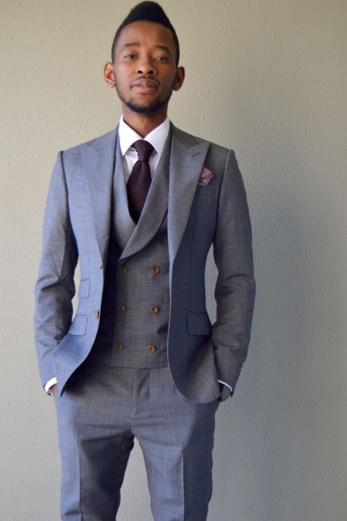

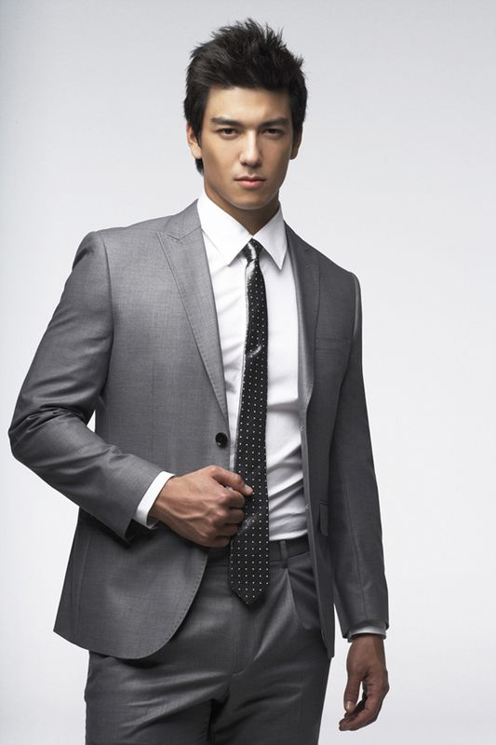

Table of Content

**Introduction3**

**Functionality……………………………………………………………………………………...3**

**Business Rules4**

**Entity Type and Relationship Types4**

**ERD Diagram 5**

**Tables & Attributes 6**

**Referential Integrities7**

**Functional Dependency Analysis for Normalization7**

**Normalized Tables8**

**Data base Creation (DDL) 9**

**Data base Data11**

**Data Description16**

**Database Data Instance18**

**SQL Table changes/Add on22**

**SQL Queries (DML) 25**

Introduction (Garrett)

Parker Suits database is responsible for maintaining and keeping track of a small tier product line of custom suits that are sought by both individual and business customers. As a database, our Items and Order line Table contain information relevant to a shipping date and a unique order number. As we have both individual and business customers it’s important for us to separate our clientele when processing orders as each have unique attributes. (I.E. an individual customer has an individual rewards No.*Business Customers do not have rewards).

As a small company with few employees we take the initiative to maintain our employee’s information as a form of security as well as determining sales output/growth and what type of customer was handled by the employee. Our database tracks what type of payment method is provided, (order-date, amount of suits, whether business or individual customer, and personal credentials I.E. name, email, etc.).

A unique database that tracks all the components provides for an efficient business model. From the time a customer places and order to the time it arrives to their residence. Everything is handled by our database. Our users are the individual consumer, business entities, and our employees maintaining our order line as they are updated

Functionality (Garrett)

The functionality for Parker Suits is designed for a user type. An employee/admin accesses the order table or order line table upon a transaction in order to verify the products customer order for accuracy. As an administrative user the functionality serves as way to verify, edit, and perform moderate duties as parker suits catalog is changed by season (I.E. price, product descriptions as well as payment details for bookkeeping). The database functions as a key component of the business tracking all facets from order date until order delivery is complete.

Business Rules

* One customer may or may not place many orders.

One order must be placed by one and only one customer.

* One order must contain one or more item.

One item may or may not be in many orders.

* One employee may or may not process many orders.

One order must be processed by one and only one employee.

* One customer must be either a business or individual customer.

One business customer or individual customer must be a customer.

Entity Types and Relationship Types

|  |  |  |  |  |
| --- | --- | --- | --- | --- |
|  | Customer | Order | Item | Employee |
| Customer | == | Place | == | == |
| Order | Placed | == | Contain | Processed |
| Item | == | Be | == | == |
| Employee | == | Process | == | == |

ERD Diagram

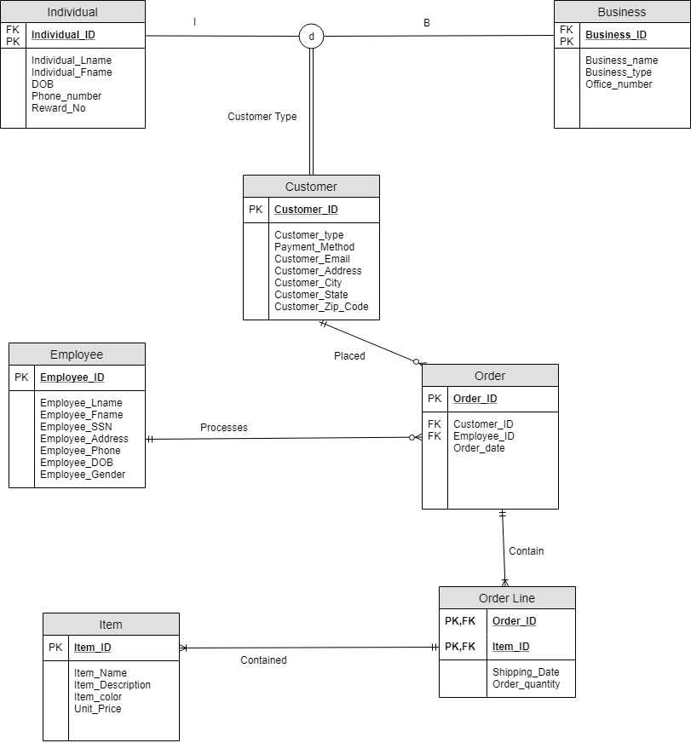

TABLES & Attributes

**Table Name:** Customer

|  |  |  |  |  |  |  |  |
| --- | --- | --- | --- | --- | --- | --- | --- |
| Customer_ID **(PK)** | Customer_type | Payment_Method | Customer_Email | Customer_Address | Customer_City | Customer_State | Customer_Zip_Code |

**Table Name:** Business

|  |  |  |  |
| --- | --- | --- | --- |
| Business_ID **(PK/FK)** | Business_type | Office_number | Business_name |

**Table Name:** Individual

|  |  |  |  |  |  |
| --- | --- | --- | --- | --- | --- |
| Individual_ID **(FK/PK)** | Individual_Lname | Individual_Fname | DOB | Phone_number | Reward_No |

**Table Name:** Order

|  |  |  |  |
| --- | --- | --- | --- |
| Order_ID **(PK)** | Employee_ID **(FK)** | Customer_ID  **(FK)** | Order_date |

**Table Name:** Item

|  |  |  |  |  |
| --- | --- | --- | --- | --- |
| Item_ID **(PK)** | Item_Name | Item_Description | Unit_Price | Item Color |

**Table Name:** Order Line

|  |  |  |  |
| --- | --- | --- | --- |
| Item_ID **(PK,FK) Composite** | Order_ID **(PK,FK)**  **Composite** | Order_quantity | Shipping_Date |

**Table Name:** Employee

|  |  |  |  |  |  |  |  |
| --- | --- | --- | --- | --- | --- | --- | --- |
| Employee_ID **(PK)** | Employee_Lname | Employee_Fname | Employee_SSN | Employee_Address | Employee_Phone | Employee_DOB | Employee_Gender |

Referential Integrities

Order, Employee_ID🡪Employee, Employee_ID

Order, Customer_ID🡪Customer, Customer_ID

Order Line, Order_ID🡪Order, Order_ID

Order Line, Item_ID🡪Item, Item_ID

Business, Business_ID🡪 Customer, Customer_ID

Individual, Individual_ID🡪 Customer, Customer_ID

Functional Dependency Analysis for Normalization

**TABLE CUSTOMER**

**Customer_ID** 🡪 Customer_type, Payment_Method, Customer_Email, Customer_Address, Customer_City, Customer_State, Customer_Zip_Code **(Full Dependency)**

**TABLE ORDER**

**Order_ID** 🡪 Employee_ID, Customer_ID, Order_Date **(Full Dependency)**

**TABLE ITEM**

**Item_ID** 🡪 Item_Name, Item_Description, Item_Color, Unit_Price **(Full Dependency)**

**TABLE ORDER LINE**

**Order_ID, Item_ID** 🡪, Order_quantity, Shipping_date **(Full Dependency)**

**TABLE EMPLOYEE**

**Employee_ID** 🡪 Employee_Lname, Employee_Fname, Employee_SSN, Employee_Address, Employee_Phone, Employee_DOB, Employee_Gender **(Full Dependency)**

**TABLE BUSINESS**

**Business_ID** 🡪 Business_Type, Office_Number, Business_Name **(Full Dependency)**

**TABLE INDIVIDUAL**

**Individual_ID** 🡪 Individual_LName, Individual_FName DOB, Phone_Number, Individual_Reward_No **(Full Dependency)**

Normalized Tables

|  |  |  |  |
| --- | --- | --- | --- |
| **Table Name** | **1NF** | **2NF** | **3NF** |
| **Customer** | X | X | X |
| **Order** | X | X | X |
| **Item** | X | X | X |
| **Order Line** | X | X | X |
| **Employee** | X | X | X |
| **Business** | X | X | X |
| **Individual** | X | X | X |

Data Base Creation (DDL)

**--Miguel**

**--Customer Table**

CREATE TABLE Customer_T

(Customer_ID NUMBER NOT NULL,

Customer_type VARCHAR(20),

Payment_Method VARCHAR(20),

Customer_Email VARCHAR(40),

Customer_Address VARCHAR(30),

Customer_City VARCHAR(20),

Customer_State VARCHAR(4),

Customer_Zip_Code VARCHAR(10),

CONSTRAINT CUSTOMER_PK PRIMARY KEY (Customer_ID));

--Miguel

**--Individual** **Table**

CREATE TABLE individual_T

(Individual_ID NUMBER NOT NULL,

Individual_Lname VARCHAR(25),

Individual_Fname VARCHAR(25),

DOB DATE,

Phone_number VARCHAR(15) UNIQUE,

Reward_No VARCHAR(9) UNIQUE,

CONSTRAINT INDIVIDUAL_PK PRIMARY KEY (individual_ID),

FOREIGN KEY (Individual_ID) REFERENCES Customer_T(Customer_ID));

--Miguel

**--Business Table**

CREATE TABLE business_T

(Business_ID NUMBER NOT NULL,

Business_name VARCHAR(25),

Business_type VARCHAR(25),

Office_number VARCHAR(15),

CONSTRAINT BUSINESS_PK PRIMARY KEY (Business_ID),

FOREIGN KEY (Business_ID) REFERENCES Customer_t(Customer_ID));

--Garrett

--**Employee Table**

CREATE TABLE Employee_T

(Employee_ID NUMBER NOT NULL,

Employee_Lname VARCHAR(25),

Employee_Fname VARCHAR(25),

Employee_SSN VARCHAR(11) UNIQUE,

Employee_Address VARCHAR(40),

Employee_Phone VARCHAR(15) UNIQUE,

Employee_DOB DATE,

Employee_gender VARCHAR(8),

CONSTRAINT EMPLOYEE_PK PRIMARY KEY (Employee_ID));

-- Richard

--**Item Table**

CREATE TABLE Item_T

(Item_ID NUMBER NOT NULL,

Item_name VARCHAR(25),

Item_description VARCHAR(50),

Item_color VARCHAR(10),

Unit_Price DECIMAL(6,2),

CONSTRAINT ITEM_PK PRIMARY KEY (Item_ID));

-- Garret

--**Order Table**

CREATE TABLE Order_T

(Order_ID INTEGER NOT NULL,

Customer_ID NUMBER,

Employee_ID NUMBER,

Order_date DATE,

CONSTRAINT ORDER_PK PRIMARY KEY (Order_ID),

CONSTRAINT ORDER_FK1 FOREIGN KEY (Customer_ID) REFERENCES Customer_T(Customer_ID),

CONSTRAINT ORDER_FK2 FOREIGN KEY (Employee_ID) REFERENCES Employee_T(Employee_ID));

--Garrett

--**Order Line Table**

CREATE TABLE Order_Line_T

(Order_ID INTEGER NOT NULL,

Item_ID NUMBER NOT NULL,

Order_quantity NUMBER CHECK (Order_quantity > 0),

Shipping_Date DATE,

CONSTRAINT ORDER_LINE_PK PRIMARY KEY (Order_ID, Item_ID),

CONSTRAINT ORDER_LINE_FK1 FOREIGN KEY (Order_ID) REFERENCES Order_T(Order_ID),

CONSTRAINT ORDER_LINE_FK2 FOREIGN KEY (Item_ID) REFERENCES Item_T(Item_ID));

Data Base Data (Miguel, Garret, Richard)

**--**Richard

**--CUSTOMER TABLE**

INSERT INTO Customer_T (Customer_ID, Customer_type, Payment_Method, Customer_Email, Customer_Address, Customer_City, Customer_State, Customer_Zip_Code)

VALUES (101, 'I', 'Visa', 'Oreocookie@firemail.com', '1800 Roller Ave', 'Atlanta', 'GA', '30309');

INSERT INTO Customer_T (Customer_ID, Customer_type, Payment_Method, Customer_Email, Customer_Address, Customer_City, Customer_State, Customer_Zip_Code)

VALUES (102, 'B', 'Mastercard', 'Biscuit@badmail.com', '7512 Country Lane Road #101', 'Topeka', 'KS', '68909');

INSERT INTO Customer_T (Customer_ID, Customer_type, Payment_Method, Customer_Email, Customer_Address, Customer_City, Customer_State, Customer_Zip_Code)

VALUES (103, 'B', 'Paypal', 'Gingerbread@bettermail.com', '1029 Lemon Blvd', 'Anchorage', 'AK', '99514');

INSERT INTO Customer_T (Customer_ID, Customer_type, Payment_Method, Customer_Email, Customer_Address, Customer_City, Customer_State, Customer_Zip_Code)

VALUES (104, 'I', 'Bitcoin', 'Paradise@squirrelmail.com', '1001 History Ln', 'Jackson', 'MI', '49201');

INSERT INTO Customer_T (Customer_ID, Customer_type, Payment_Method, Customer_Email, Customer_Address, Customer_City, Customer_State, Customer_Zip_Code)

VALUES (105, 'B', 'Visa', 'Marmalade@badmail.com', '101 First St.', 'Augusta', 'ME', '04330');

INSERT INTO Customer_T (Customer_ID, Customer_type, Payment_Method, Customer_Email, Customer_Address, Customer_City, Customer_State, Customer_Zip_Code)

VALUES (106, 'I', 'Venmo', 'Ralphsbest@bettermail.com', '1020 State St.', 'New York', 'NY', '10001');

INSERT INTO Customer_T (Customer_ID, Customer_type, Payment_Method, Customer_Email, Customer_Address, Customer_City, Customer_State, Customer_Zip_Code)

VALUES (107, 'B', 'Amex', 'TammyJ@gmail.com', '1453 Chocolate Blvd', 'Orlando', 'FL', '32812');

INSERT INTO Customer_T (Customer_ID, Customer_type, Payment_Method, Customer_Email, Customer_Address, Customer_City, Customer_State, Customer_Zip_Code)

VALUES (108, 'I', 'Apple Pay', 'JM@bettermail.com', '6606 Sand Rd.', 'Dallas', 'TX', '75001');

INSERT INTO Customer_T (Customer_ID, Customer_type, Payment_Method, Customer_Email, Customer_Address, Customer_City, Customer_State, Customer_Zip_Code)

VALUES (109, 'I', 'Discover', 'JJ@gmail.com', '8812 Old Rd.', 'Sacramento', 'CA', '94261');

INSERT INTO Customer_T (Customer_ID, Customer_type, Payment_Method, Customer_Email, Customer_Address, Customer_City, Customer_State, Customer_Zip_Code)

VALUES (110, 'I', 'Android Pay', 'MMlove@bettermail.com', '720 Melon Cove', 'Miami', 'FL', '33234');

INSERT INTO Customer_T (Customer_ID, Customer_type, Payment_Method, Customer_Email, Customer_Address, Customer_City, Customer_State, Customer_Zip_Code)

VALUES (201, 'B', 'Cash', 'TomeJones@gmail.com', '1000 Grand Blvd. #30', 'Nashville', 'TN', '37027');

INSERT INTO Customer_T (Customer_ID, Customer_type, Payment_Method, Customer_Email, Customer_Address, Customer_City, Customer_State, Customer_Zip_Code)

VALUES (202, 'I', 'Check', 'RickyRicardo@gmail.com', '2042 Coconut Ave.', 'Dallas', 'TX', '75001');

INSERT INTO Customer_T (Customer_ID, Customer_type, Payment_Method, Customer_Email, Customer_Address, Customer_City, Customer_State, Customer_Zip_Code)

VALUES (203, 'I', 'Check', 'KoolAid@bettermail.com', '1932 Rock St.', 'Los Angeles', 'CA', '90020');

INSERT INTO Customer_T (Customer_ID, Customer_type, Payment_Method, Customer_Email, Customer_Address, Customer_City, Customer_State, Customer_Zip_Code)

VALUES (204, 'B', 'Credit', 'Harrys@gmail.com', '1203 Eagle Blvd.', 'Los Angeles', 'CA', '90028');

INSERT INTO Customer_T (Customer_ID, Customer_type, Payment_Method, Customer_Email, Customer_Address, Customer_City, Customer_State, Customer_Zip_Code)

VALUES (205, 'I', 'Visa', 'Marias@bettermail.com', '1545 Vine St.', 'Los Angeles', 'CA', '90027');

INSERT INTO Customer_T (Customer_ID, Customer_type, Payment_Method, Customer_Email, Customer_Address, Customer_City, Customer_State, Customer_Zip_Code)

VALUES (206, 'B', 'Cash', 'ASpace@gmail.com', '3030 Figueroa Street', 'Los Angeles', 'CA', '90034');

INSERT INTO Customer_T (Customer_ID, Customer_type, Payment_Method, Customer_Email, Customer_Address, Customer_City, Customer_State, Customer_Zip_Code)

VALUES (207, 'I', 'Check', 'Arthurspad@gmail.com', '9790 Glacier Rd.', 'Baton Rouge', 'LA', '70805');

INSERT INTO Customer_T (Customer_ID, Customer_type, Payment_Method, Customer_Email, Customer_Address, Customer_City, Customer_State, Customer_Zip_Code)

VALUES (208, 'B', 'Check', 'LisSer@gmail.com', '3402 Logic Ln.', 'Austin', 'TX', '78720');

INSERT INTO Customer_T (Customer_ID, Customer_type, Payment_Method, Customer_Email, Customer_Address, Customer_City, Customer_State, Customer_Zip_Code)

VALUES (209, 'B', 'Check', ' Rd@roxon.com', '1000 Imperial Way', ' San Francisco', ' CA', '94123');

**--**Richard

**--INDIVIDUAL TABLE**

INSERT INTO INDIVIDUAL_T (Individual_ID, Individual_Lname, Individual_Fname, DOB, Phone_number, Reward_No)

VALUES (101, 'Gonzales', 'Matt', '25/FEB/1980', '323-625-7758', '853659');

INSERT INTO INDIVIDUAL_T (Individual_ID, Individual_Lname, Individual_Fname, DOB, Phone_number, Reward_No)

VALUES (202, 'Faith', 'Stella', '05-OCT-1999', '269-589-2186', '582369');

INSERT INTO INDIVIDUAL_T (Individual_ID, Individual_Lname, Individual_Fname, DOB, Phone_number, Reward_No)

VALUES (203, 'Valle', 'Gian', '16-MAY-1996', '568-258-2368', '964236');

INSERT INTO INDIVIDUAL_T (Individual_ID, Individual_Lname, Individual_Fname, DOB, Phone_number, Reward_No)

VALUES (104, 'Uruk', 'Gilgamesh', '01-JAN-2000', '421-432-5332', '112948');

INSERT INTO INDIVIDUAL_T (Individual_ID, Individual_Lname, Individual_Fname, DOB, Phone_number, Reward_No)

VALUES (205, 'Worth', 'Barnaby', '10-MAY-1991', '323-000-2323', '101243');

INSERT INTO INDIVIDUAL_T (Individual_ID, Individual_Lname, Individual_Fname, DOB, Phone_number, Reward_No)

VALUES (106, 'Lauren', 'Ralph', '01-JUNE-1946', '213-002-0918', '712431');

INSERT INTO INDIVIDUAL_T (Individual_ID, Individual_Lname, Individual_Fname, DOB, Phone_number, Reward_No)

VALUES (207, 'Jones', 'Tammy', '03-April-1982', '323-556-0012', '451986');

INSERT INTO INDIVIDUAL_T (Individual_ID, Individual_Lname, Individual_Fname, DOB, Phone_number, Reward_No)

VALUES (108, 'Meat', 'John', '06-May- 1966', '213-435-1024', '561834');

INSERT INTO INDIVIDUAL_T (Individual_ID, Individual_Lname, Individual_Fname, DOB, Phone_number, Reward_No)

VALUES (109, 'Johnson', 'John', '04-Sep-1910', '310-691-7823', '340102');

INSERT INTO INDIVIDUAL_T (Individual_ID, Individual_Lname, Individual_Fname, DOB, Phone_number, Reward_No)

VALUES (110, 'May', 'Mary', '01-DEC-1992', '341-890-9821', '300431');

**--**Richard

--**BUSINESS TABLE**

INSERT INTO Business_T (Business_ID, Business_name, Business_type, Office_number)

VALUES (201, 'Barneys Threads', 'Retail', '895-985-2586');

INSERT INTO Business_T (Business_ID, Business_name, Business_type, Office_number)

VALUES (102, 'Xyz Clothing', 'Custom Clothing', '323-931-1900');

INSERT INTO Business_T (Business_ID, Business_name, Business_type, Office_number)

VALUES (103, 'Second Hand', 'Consignment', '213-100-3201');

INSERT INTO Business_T (Business_ID, Business_name, Business_type, Office_number)

VALUES (204, 'Harry Logistics ', 'Moving Company', '323-808-6969');

INSERT INTO Business_T (Business_ID, Business_name, Business_type, Office_number)

VALUES (105, 'Marias Shop', 'Consignment', '213-452-1891');

INSERT INTO Business_T (Business_ID, Business_name, Business_type, Office_number)

VALUES (206, 'Altons Space', 'Consignment', '323-008-8734');

INSERT INTO Business_T (Business_ID, Business_name, Business_type, Office_number)

VALUES (107, 'Arthurs Old Pad', 'Retail', '323-213-4525');

INSERT INTO Business_T (Business_ID, Business_name, Business_type, Office_number)

VALUES (208, 'Liz Services', 'Moving Logistics', '323-213-1034');

INSERT INTO Business_T (Business_ID, Business_name, Business_type, Office_number)

VALUES (209, ' Roxon Designs', ' Designer', ' 323-402-7854');

**--**Garrett

--**EMPLOYEE**

INSERT INTO Employee_t (Employee_ID, Employee_Lname, Employee_Fname, Employee_SSN, Employee_address, Employee_Phone, Employee_DOB, Employee_Gender)

VALUES (1, 'Dough', 'Boy', '101-32-2012', '1200 Glorious Blvd', '323-141-0001', '01/Dec/1981', 'Male');

INSERT INTO Employee_t (Employee_ID, Employee_Lname, Employee_Fname, Employee_SSN, Employee_address, Employee_Phone, Employee_DOB, Employee_Gender)

VALUES (2, 'Jones', 'Richie', '321-22-4021', '1001 Cheap St', '213-301-4213', '02/Mar/1990', 'Male');

INSERT INTO Employee_t (Employee_ID, Employee_Lname, Employee_Fname, Employee_SSN, Employee_address, Employee_Phone, Employee_DOB, Employee_Gender)

VALUES (3, 'Ford', 'Tom', '201-01-3021', '7510 Royal Rd', '310-434-0121', '04/Aug/1970', 'Male');

INSERT INTO Employee_t (Employee_ID, Employee_Lname, Employee_Fname, Employee_SSN, Employee_address, Employee_Phone, Employee_DOB, Employee_Gender)

VALUES (4, 'Harvey', 'Lisa', '401-51-3671', '7548 Royal Rd', '330-454-6721', '04/May/1995', 'Female');

**--**Miguel

--**ITEM TABLE**

INSERT INTO Item_T (Item_ID, Item_name, Item_description, Item_color, Unit_Price)

VALUES (10, 'Kempton Suit', 'Italian Threaded Custom Blazer', 'Black', 399);

INSERT INTO Item_T (Item_ID, Item_name, Item_description, Item_color, Unit_Price)

VALUES (20, 'Broadway Suit', 'Polyester Cotton Jacket', 'Grey', 100);

INSERT INTO Item_T (Item_ID, Item_name, Item_description, Item_color, Unit_Price)

VALUES (30, 'Matte Suit', 'Long Sleeve Collared Button Up', 'White', 75);

INSERT INTO Item_T (Item_ID, Item_name, Item_description, Item_color, Unit_Price)

VALUES (40, 'Razor Tie', 'Full Length Silk Accessory', 'Red', 50);

**--**Garrett

--**ORDER TABLE**

INSERT INTO Order_T (Order_ID, Customer_ID, Employee_ID, Order_date)

VALUES (1001, 101, 1, '10-SEP-19');

INSERT INTO Order_T (Order_ID, Customer_ID, Employee_ID, Order_date)

VALUES (1002, 105, 3, '31-OCT-19');

INSERT INTO Order_T (Order_ID, Customer_ID, Employee_ID, Order_date)

VALUES (1003, 203, 3, '24-SEP-19');

INSERT INTO Order_T (Order_ID, Customer_ID, Employee_ID, Order_date)

VALUES (1004, 106, 4, '03-NOV-19');

INSERT INTO Order_T (Order_ID, Customer_ID, Employee_ID, Order_date)

VALUES (1005, 201, 3, '04-AUG-19');

INSERT INTO Order_T (Order_ID, Customer_ID, Employee_ID, Order_date)

VALUES (1006, 103, 1, '09-NOV-19');

INSERT INTO Order_T (Order_ID, Customer_ID, Employee_ID, Order_date)

VALUES (1007, 209, 2, '15-OCT-19');

INSERT INTO Order_T (Order_ID, Customer_ID, Employee_ID, Order_date)

VALUES (1008, 109, 1, '01-SEP-19');

INSERT INTO Order_T (Order_ID, Customer_ID, Employee_ID, Order_date)

VALUES (1009, 101, 2, '31-OCT-19');

INSERT INTO Order_T (Order_ID, Customer_ID, Employee_ID, Order_date)

VALUES (1010, 102, 3, '08-AUG-19');

**--**Miguel

--**ORDER LINE TABLE**

INSERT INTO Order_Line_T (order_ID, Item_ID, Order_Quantity, Shipping_Date)

VALUES (1001, 40, 2, '31-Oct-19');

INSERT INTO Order_Line_T (order_ID, Item_ID, Order_Quantity, Shipping_Date)

VALUES (1002, 20, 1, '7-Aug-19');

INSERT INTO Order_Line_T (order_ID, Item_ID, Order_Quantity, Shipping_Date)

VALUES (1003, 10, 1, '12-Nov-19');

INSERT INTO Order_Line_T (order_ID, Item_ID, Order_Quantity, Shipping_Date)

VALUES (1005, 20, 1, '05-Sep-19');

INSERT INTO Order_Line_T (order_ID, Item_ID, Order_Quantity, Shipping_Date)

VALUES (1010, 30, 2, '2-Nov-19');

COMMIT;

DESC Individual_T;

DESC business_T;

DESC Customer_t

DESC Order_T;

DESC Employee_T;

DESC Item_T;

DESC Order_Line_T;

Database Description

**Individual Table**

|  |  |  |
| --- | --- | --- |
| **Name** | **Null?** | **Type** |
| INDIVIDUAL_ID | NOT NULL | NUMBER |
| INDIVIDUAL_LNAME |  | VARCHAR2(25) |
| INDIVIDUAL_FNAME |  | VARCHAR2(25) |
| DOB |  | DATE |
| PHONE_NUMBER |  | VARCHAR2(15) |
| REWARD_NO |  | VARCHAR2(9) |

**Business Table**

|  |  |  |
| --- | --- | --- |
| **Name** | **Null?** | **Type** |
| BUSINESS_ID | NOT NULL | NUMBER |
| BUSINESS_NAME |  | VARCHAR2(25) |
| BUSINESS_TYPE |  | VARCHAR2(25) |
| OFFICE_NUMBER |  | VARCHAR2(15) |

**Customer Table**

|  |  |  |
| --- | --- | --- |
| **Name** | **Null?** | **Type** |
| CUSTOMER_ID | NOT NULL | NUMBER |
| CUSTOMER_TYPE |  | VARCHAR2(20) |
| PAYMENT_METHOD |  | VARCHAR2(20) |
| CUSTOMER_EMAIL |  | VARCHAR2(40) |
| CUSTOMER_ADDRESS |  | VARCHAR2(30) |
| CUSTOMER_CITY |  | VARCHAR2(20) |
| CUSTOMER_STATE |  | VARCHAR2(4) |
| CUSTOMER_ZIP_CODE |  | VARCHAR2(10) |

**Order Table**

|  |  |  |
| --- | --- | --- |
| **Name** | **Null?** | **Type** |
| ORDER_ID | NOT NULL | NUMBER(38) |
| CUSTOMER_ID |  | NUMBER |
| EMPLOYEE_ID |  | NUMBER |
| ORDER_DATE |  | DATE |

**Employee Table**

|  |  |  |
| --- | --- | --- |
| **Name** | **Null?** | **Type** |
| EMPLOYEE_ID | NOT NULL | NUMBER |
| EMPLOYEE_LNAME |  | VARCHAR2(25) |
| EMPLOYEE_FNAME |  | VARCHAR2(25) |
| EMPLOYEE_SSN |  | VARCHAR2(11) |
| EMPLOYEE_ADDRESS |  | VARCHAR2(40) |
| EMPLOYEE_PHONE |  | VARCHAR2(15) |
| EMPLOYEE_DOB |  | DATE |
| EMPLOYEE_GENDER |  | VARCHAR2(8) |

**Item Table**

|  |  |  |
| --- | --- | --- |
| **Name** | **Null?** | **Type** |
| ITEM_ID | NOT NULL | NUMBER |
| ITEM_NAME |  | VARCHAR2(25) |
| ITEM_DESCRIPTION |  | VARCHAR2(50) |
| ITEM_COLOR |  | VARCHAR2(10) |
| UNIT_PRICE |  | NUMBER(6,2) |

**Order Line Table**

|  |  |  |
| --- | --- | --- |
| **Name** | **Null?** | **Type** |
| ORDER_ID | NOT NULL | NUMBER(38) |
| ITEM_ID | NOT NULL | NUMBER |
| ORDER_QUANTITY |  | NUMBER |
| SHIPPING_DATE |  | DATE |

Database Data Instance

**Customer Table**

**SELECT * FROM Customer_t;**

|  |  |  |  |  |  |  |  |
| --- | --- | --- | --- | --- | --- | --- | --- |
| **CUSTOMER_ID** | **CUSTOMER_TYPE** | **PAYMENT_METHOD** | **CUSTOMER_EMAIL** | **CUSTOMER_ADDRESS** | **CUSTOMER_CITY** | **CUSTOMER_STA** | **CUSTOMER_ZIP_CODE** |
| 101 | I | Visa | Oreocookie@firemail.com | 1800 Roller Ave | Atlanta | GA | 30309 |
| 102 | B | Mastercard | Biscuit@badmail.com | 7512 Country Lane Road #101 | Topeka | KS | 68909 |
| 103 | B | Paypal | Gingerbread@bettermail.com | 1029 Lemon Blvd | Anchorage | AK | 99514 |
| 104 | I | Bitcoin | Paradise@squirrelmail.com | 1001 History Ln | Jackson | MI | 49201 |
| 105 | B | Visa | Marmalade@badmail.com | 101 First St. | Augusta | ME | 04330 |
| 106 | I | Venmo | Ralphsbest@bettermail.com | 1020 State St. | New York | NY | 10001 |
| 107 | B | Amex | TammyJ@gmail.com | 1453 Chocolate Blvd | Orlando | FL | 32812 |
| 108 | I | Apple Pay | JM@bettermail.com | 6606 Sand Rd. | Dallas | TX | 75001 |
| 109 | I | Discover | JJ@gmail.com | 8812 Old Rd. | Sacramento | CA | 94261 |
| 110 | I | Android Pay | MMlove@bettermail.com | 720 Melon Cove | Miami | FL | 33234 |
| 201 | B | Cash | TomeJones@gmail.com | 1000 Grand Blvd. #30 | Nashville | TN | 37027 |
| 202 | I | Check | RickyRicardo@gmail.com | 2042 Coconut Ave. | Dallas | TX | 75001 |
| 203 | I | Check | KoolAid@bettermail.com | 1932 Rock St. | Los Angeles | CA | 90020 |
| 204 | B | Credit | Harrys@gmail.com | 1203 Eagle Blvd. | Los Angeles | CA | 90028 |
| 205 | I | Visa | Marias@bettermail.com | 1545 Vine St. | Los Angeles | CA | 90027 |
| 206 | B | Cash | ASpace@gmail.com | 3030 Figueroa Street | Los Angeles | CA | 90034 |
| 207 | I | Check | Arthurspad@gmail.com | 9790 Glacier Rd. | Baton Rouge | LA | 70805 |
| 208 | B | Check | LisSer@gmail.com | 3402 Logic Ln. | Austin | TX | 78720 |
| 209 | B | Check | Rd@roxon.com | 1000 Imperial Way | San Francisco | CA | 94123 |

**Individual Table**

**SELECT * FROM Individual_T;**

|  |  |  |  |  |  |
| --- | --- | --- | --- | --- | --- |
| **INDIVIDUAL_ID** | **INDIVIDUAL_LNAME** | **INDIVIDUAL_FNAME** | **DOB** | **PHONE_NUMBER** | **REWARD_NO** |
| 101 | Gonzales | Matt | 25-FEB-80 | 323-625-7758 | 853659 |
| 202 | Faith | Stella | 05-OCT-99 | 269-589-2186 | 582369 |
| 203 | Valle | Gian | 16-MAY-96 | 568-258-2368 | 964236 |
| 104 | Uruk | Gilgamesh | 01-JAN-00 | 421-432-5332 | 112948 |
| 205 | Worth | Barnaby | 10-MAY-91 | 323-000-2323 | 101243 |
| 106 | Lauren | Ralph | 01-JUN-46 | 213-002-0918 | 712431 |
| 207 | Jones | Tammy | 03-APR-82 | 323-556-0012 | 451986 |
| 108 | Meat | John | 06-MAY-66 | 213-435-1024 | 561834 |
| 109 | Johnson | John | 04-SEP-10 | 310-691-7823 | 340102 |
| 110 | May | Mary | 01-DEC-92 | 341-890-9821 | 300431 |

**Business Table**

**SELECT * FROM business_T;**

|  |  |  |  |
| --- | --- | --- | --- |
| **BUSINESS_ID** | **BUSINESS_NAME** | **BUSINESS_TYPE** | **OFFICE_NUMBER** |
| 201 | Barneys Threads | Retail | 895-985-2586 |
| 102 | Xyz Clothing | Custom Clothing | 323-931-1900 |
| 103 | Second Hand | Consignment | 213-100-3201 |
| 204 | Harry Logistics | Moving Company | 323-808-6969 |
| 105 | Marias Shop | Consignment | 213-452-1891 |
| 206 | Altons Space | Consignment | 323-008-8734 |
| 107 | Arthurs Old Pad | Retail | 323-213-4525 |
| 208 | Liz Services | Moving Logistics | 323-213-1034 |
| 209 | Roxon Designs | Designer | 323-402-7854 |

**Employee Table**

**SELECT * FROM Employee_T;**

|  |  |  |  |  |  |  |  |
| --- | --- | --- | --- | --- | --- | --- | --- |
| **EMPLOYEE_ID** | **EMPLOYEE_LNAME** | **EMPLOYEE_FNAME** | **EMPLOYEE_SSN** | **EMPLOYEE_ADDRESS** | **EMPLOYEE_PHONE** | **EMPLOYEE_DOB** | **EMPLOYEE_GENDER** |
| 1 | Dough | Boy | 101-32-2012 | 1200 Glorious Blvd | 323-141-0001 | 01-DEC-81 | Male |
| 2 | Jones | Richie | 321-22-4021 | 1001 Cheap St | 213-301-4213 | 02-MAR-90 | Male |
| 3 | Ford | Tom | 201-01-3021 | 7510 Royal Rd | 310-434-0121 | 04-AUG-70 | Male |
| 4 | Harvey | Lisa | 401-51-3671 | 7548 Royal Rd | 330-454-6721 | 04-MAY-95 | Female |

**Item Table**

**SELECT * FROM Item_T;**

|  |  |  |  |  |
| --- | --- | --- | --- | --- |
| **ITEM_ID** | **ITEM_NAME** | **ITEM_DESCRIPTION** | **ITEM_COLOR** | **UNIT_PRICE** |
| 10 | Kempton Suit | Italian Threaded Custom Blazer | Black | 399 |
| 20 | Broadway Suit | Polyester Cotton Jacket | Grey | 100 |
| 30 | Matte Suit | Long Sleeve Collared Button Up | White | 75 |
| 40 | Razor Tie | Full Length Silk Accessory | Red | 50 |

**Order Table**

**SELECT * FROM Order_T;**

|  |  |  |  |
| --- | --- | --- | --- |
| **ORDER_ID** | **CUSTOMER_ID** | **EMPLOYEE_ID** | **ORDER_DATE** |
| 1001 | 101 | 1 | 10-SEP-19 |
| 1002 | 105 | 3 | 31-OCT-19 |
| 1003 | 203 | 3 | 24-SEP-19 |
| 1004 | 106 | 4 | 03-NOV-19 |
| 1005 | 201 | 3 | 04-AUG-19 |
| 1006 | 103 | 1 | 09-NOV-19 |
| 1007 | 209 | 2 | 15-OCT-19 |
| 1008 | 109 | 1 | 01-SEP-19 |
| 1009 | 101 | 2 | 31-OCT-19 |
| 1010 | 102 | 3 | 08-AUG-19 |

**Order Line Table**

**SELECT * FROM Order_Line_T**

|  |  |  |  |
| --- | --- | --- | --- |
| **ORDER_ID** | **ITEM_ID** | **ORDER_QUANTITY** | **SHIPPING_DATE** |
| 1001 | 40 | 2 | 31-OCT-19 |
| 1002 | 20 | 1 | 07-AUG-19 |
| 1003 | 10 | 1 | 12-NOV-19 |
| 1005 | 20 | 1 | 05-SEP-19 |
| 1010 | 30 | 2 | 02-NOV-19 |

SQL Table changes/add on

* Garrett
* Insert a new business customer

**INSERT INTO** Customer_T (Customer_ID, Customer_type, Payment_Method, Customer_Email, Customer_Address, Customer_City, Customer_State, Customer_Zip_Code)

VALUES (111, 'B', 'Mastercard', 'RTGroup@me.com', '1309 Vine St.', 'Los Angeles', 'CA', '90027');

|  |  |  |  |  |  |  |  |
| --- | --- | --- | --- | --- | --- | --- | --- |
| 111 | B | Mastercard | RTGroup@me.com | 1309 Vine St. | Los Angeles | CA | 90027 |

**INSERT INTO** Business_T (Business_ID, Business_name, Business_type, Office_number)

VALUES (111, 'RT Association', ' Designer', ' 323-456-5672');

|  |  |  |  |
| --- | --- | --- | --- |
| **BUSINESS_ID** | **BUSINESS_NAME** | **BUSINESS_TYPE** | **OFFICE_NUMBER** |
| 111 | RT Association | Designer | 323-456-5672 |

* Richard
* Change the Unit price of item ID 10 to $50 less.

**UPDATE** Item_T

SET Unit_Price = 349

WHERE Item_ID = 10;

|  |  |  |  |  |
| --- | --- | --- | --- | --- |
| **ITEM_ID** | **ITEM_NAME** | **ITEM_DESCRIPTION** | **ITEM_COLOR** | **UNIT_PRICE** |
| 10 | Kempton Suit | Italian Threaded Custom Blazer | Black | 349 |

* Miguel
* Order ID 1008 has been cancelled. Remove it from the service.

**DELETE FROM** Order_T

WHERE order_ID = 1008;

|  |  |  |  |
| --- | --- | --- | --- |
| 1007 | 209 | 2 | 15-OCT-19 |
| 1009 | 101 | 2 | 31-OCT-19 |
| 1010 | 102 | 3 | 08-AUG-19 |

* Miguel
* Create a view for all customer in CA.

**CREATE VIEW** CA_Cust

AS

SELECT *

FROM customer_t

WHERE customer_state IN ('CA');

View created.

SELECT *

FROM Ca_Cust;

|  |  |  |  |  |  |  |  |
| --- | --- | --- | --- | --- | --- | --- | --- |
| **CUSTOMER_ID** | **CUSTOMER_TYPE** | **PAYMENT_METHOD** | **CUSTOMER_EMAIL** | **CUSTOMER_ADDRESS** | **CUSTOMER_CITY** | **CUSTOMER_STA** | **CUSTOMER_ZIP_CODE** |
| 109 | I | Discover | JJ@gmail.com | 8812 Old Rd. | Sacramento | CA | 94261 |
| 203 | I | Check | KoolAid@bettermail.com | 1932 Rock St. | Los Angeles | CA | 90020 |
| 204 | B | Credit | Harrys@gmail.com | 1203 Eagle Blvd. | Los Angeles | CA | 90028 |
| 205 | I | Visa | Marias@bettermail.com | 1545 Vine St. | Los Angeles | CA | 90027 |
| 206 | B | Cash | ASpace@gmail.com | 3030 Figueroa Street | Los Angeles | CA | 90034 |

SQL Queries (DML)

**Garrett Tice**

**--**List items with more than one order

SELECT Item_ID, COUNT(Order_quantity) AS Orders_with_that_item

FROM Order_line_t

GROUP BY Item_id, Order_quantity

Having Count (order_quantity) =1

ORDER BY Item_ID DESC;

|  |  |
| --- | --- |
| **ITEM_ID** | **ORDERS_WITH_THAT_ITEM** |
| 40 | 1 |
| 30 | 1 |
| 10 | 1 |

By changing the HAVING COUNT (Order_quantity) > 1 --- It will give the amount of orders that have that item

|  |  |
| --- | --- |
| **ITEM_ID** | **ORDERS_WITH_THAT_ITEM** |
| 20 | 2 |

**Miguel Guzman**

--List Individual Customers that have placed and not placed and order

--Placed an order

SELECT Individual_Lname, Individual_Fname, Customer_ID

FROM Individual_T, Customer_T

WHERE Individual_T. Individual_ID = Customer_T.Customer_ID

AND Customer_ID IN

(SELECT Customer_ID

FROM Order_T);

|  |  |  |
| --- | --- | --- |
| **INDIVIDUAL_LNAME** | **INDIVIDUAL_FNAME** | **CUSTOMER_ID** |
| Gonzales | Matt | 101 |
| Valle | Gian | 203 |
| Lauren | Ralph | 106 |
| Johnson | John | 109 |

--Not placed an order

SELECT Individual_Lname, Individual_Fname, Customer_ID

FROM Individual_T, Customer_T

WHERE Individual_T. Individual_ID = Customer_T.Customer_ID

AND Customer_ID NOT IN

(SELECT Customer_ID

FROM Order_T);

|  |  |  |
| --- | --- | --- |
| **INDIVIDUAL_LNAME** | **INDIVIDUAL_FNAME** | **CUSTOMER_ID** |
| Faith | Stella | 202 |
| Uruk | Gilgamesh | 104 |
| Worth | Barnaby | 205 |
| Jones | Tammy | 207 |
| Meat | John | 108 |
| May | Mary | 110 |

**Richard Hidajat**

--Display employeeID who assisted more than 2 orders.

SELECT employee_id, COUNT (order_id)

FROM order_t

GROUP BY employee_id

HAVING COUNT(order_id) > 2;

|  |  |
| --- | --- |
| **EMPLOYEE_ID** | **COUNT(ORDER_ID)** |
| 1 | 3 |
| 3 | 4 |